Wearing a Great Britain vest has to be one of the proudest moments in any athlete’s career, and last weekend I wore the red, white and blue kit for the first time at the 12th European Mountain Running Championships in Bulgaria (uphill only). The Great Britain and Northern Ireland team, which had been selected after the European Trial on Skiddaw in May, travelled to the Championships in Borovets with the aim of bringing back as many medals as possible. This was undoubtedly going to be a challenge as the races were to finish at a breathtaking altitude of 2360m; higher than any other European Championships have ever been held before. Not forgetting that after last year’s up and down championships in Turkey, the race would be uphill only, something the other European teams are notoriously stronger at. However, we did not let this stand in our way as we travelled home with three team medals.
After an early start, I was on the start line of the Junior Women’s race, along with team mates Catriona Graves, Annabel Mason and Lydia Sharpe. At 9 o’clock we began to make our way up the steepest of all four courses in the Championship, which consisted of 530m of rocky ascent over only 3.5km. As expected the Turkish team lead the race out hard and fast but the rest of the field soon caught them up, lead by Melaine Albrecht from Germany, who went on to win the race in 25:49. The Great Britain and Northern Ireland girls packed well and over the final couple of kilometres Scot Catriona Graves showed her uphill talent to finish 6th in a time of 27:58. Defending European Champion Annabel Mason did well after recent struggles with injury to take 8th position in 28:14. I finished just outside the top 10 in 12th position in a time of 29:06. Lydia Sharpe was 21st in 30:18. Russia took the team gold but they were closely followed by GB who were only two points behind. It is important to note that with three of the four athletes in the junior women’s team born in 1996 (me, Annabel and Catriona) it means that we all still have 2 more years in the junior age group. With such a young team at this Championship hopefully we will get stronger and more experienced over the next few years so that we can convert our silver medals to gold ones!
Up next was the junior men’s race, which was a more scenic 8.8km with a more gradual ascent but equally as tough. Turkey dominated this race, with Ramazan Karagoz effortlessly taking gold in a time of 48:51, followed up by teammate Sehmus Sarihan who was 63 seconds behind. Max Wharton from Calder Valley had a particularly impressive run to lead the GB team home in a time of 53:09. Max was followed up by Nathan Jones from Wales, Brad Traviss who also runs for Calder Valley and Scotland’s Andrew Lawler who finished in 19th, 29th and 34th respectively.
The senior women’s race took the same gruelling route as the junior boys. It was always going to be an uphill battle for the GB team to retain the gold team medal they won at last year’s Championships, as the other European countries are always particularly strong when it comes to uphill only races. However, the girls took bronze with only Italy and Switzerland beating them in the team competition. Emma Clayton from Bingley Harriers once again showed her incredible form to lead the team home in style, finishing in 6th place in a time of 55:16. The bronze medal team was completed by Olivia Walwyn in 21st, Sarah Tunstall in 25th and Rebecca Robinson in 39th. Austrian Andrea Mayr won the race in 51:49.
At the medal ceremony for the senior men it felt as though the Italian National Anthem was on repeat with Italy taking the team prize, as a result of them grabbing the top two spots. The winner Bernard Dematteis finished in a time of 56:30 ahead of Alex Baldaccini who completed the 11.8km course in 57:35. Impressively the Italian duo managed to put an end to the Turkish Mountain Running legend Ahmet Arslan’s winning streak, which has been an unstoppable force in the world of Mountain Running since 2007 when he won his first of six successive European victories. However, the GB men took the silver medal position on the podium after Steve Vernon showed his class as an athlete finishing in 5th (58:33), the highest position a Brit has ever finished at these Championships. The rest of the GB men had impressive runs with Chris Smith finishing in 8th, Orlando Edwards in 18th and Robbie Simpson in 29th.
I don’t think it is possible to describe the atmosphere in Borovets last weekend or how amazing the experience was! Although the race tough (check out this video http://www.youtube.com/watch?v=_8Ic5pDMgeM which doesn’t even show the steepest parts of the climb!!) I would do it over and over again if I could! I am now more motivated than ever to do well at the World trial in August so that I can wear my GB kit again and see what happens when team GB take on the rest of the World at an up and down race!!
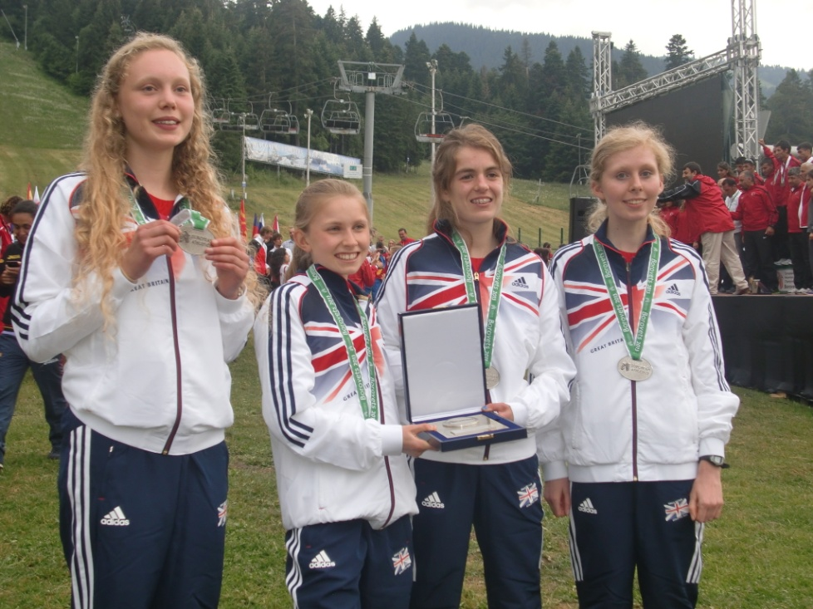
By Georgia Malir

